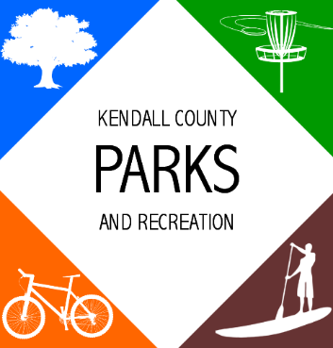
AGENDA
Parks Advisory Board Meeting
6:00 PM- December 14, 2021

Ring Mountain Event Center
716 FM 289 Comfort, TX 78013

- Call to Order
- Public Comments- Opportunity for the general public to address the advisory board on any matter. The advisory board may not discuss any presented issue, nor may any action be taken on any issue at this time. Comments are limited to 3 minutes.

- Approval of Minutes
- Adoption of Minutes
Parks Advisory Board- September 28, 2021- Minutes & December 13, 2021- Minutes
- Announcements/Reminders
- Parks Advisory Board Bylaws
- Consideration and Action
- Discuss a permanent board meeting schedule.
- Discuss and establish a plan for park improvements with available ARPA funds to present to the Commissioners Court on December 27, 2021.

- Staff Reports
- Traffic Reports
- Survey Update
- Future Agenda Items
- Land Donation Criteria
- Adjournment

